3.1 Addition and Multiplication of Two Sequences
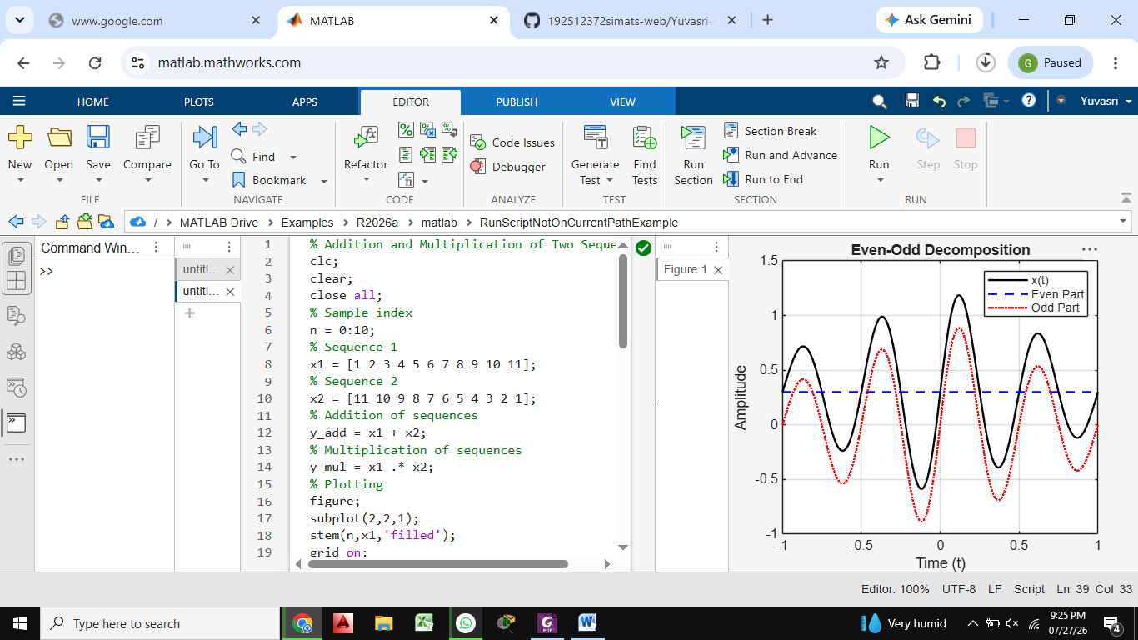

3.3 Autocorrelation
